Malaria in Mozambique:
  - Predicting incidence using weather and intervention data

Background:
Caused by a protozoan parasite transmitted to humans via mosquito bite, Malaria infects hundreds of millions of people each year. With 13 countries, mainly in Sub-Saharan Africa, bearing 76% of the world’s malaria cases each year, intervention efforts to reduce transmission have become commonplace¹. Individuals who have contracted malaria often show early symptoms of chills, fever, and chills. If left undiagnosed or untreated, an ill person may develop cerebral malaria, often perishing as a result. Interestingly, adults who grew up in regions where malaria is endemic often develop some level of immunity to the parasite and can have asymptomatic infections¹. It is for this reason that data for children who have contracted malaria is used in this study, as they are more likely to visit a clinic to receive treatment.

Weather:
Malaria parasites grow optimally in climates with at least 60% humidity and average temperatures of 20-30 degrees Celsius³. Mozambique has averages temperatures around 28 degrees Celsius and yearly average rainfall of 85 centimeters. 82% of this rainfall comes between the months of March and November². Such conditions make Mozambique an ideal climate for malaria to flourish. The mosquitos that transmit malaria benefit from rainfall to complete their own life cycle. Circumstances in which there are manmade environmental changes, such as large bodies of stagnant water, can be prime breeding grounds for both the malaria parasite and its mosquito hosts. Periods of heavy rainfall and high temperatures have been shown to predict an increase in malaria incidence in the weeks that follow.

Transmission and Incubation:
Living a relatively complex life cycle, a parasite enters a human host through a mosquito’s saliva and incubate in the liver, before releasing themselves to infect and destroy red blood cells. It is the bursting of red blood cells in which the parasite has grown and multiplied that causes symptoms. An incubation period of roughly 2 weeks is typical between time of infection and onset of symptoms. However, studies have shown that exposure can occur 4 or even 8 weeks before a person becomes symptomatic (_____).

Interventions:
Two common interventions employed are insecticide treated mosquito nets (ITNs) and indoor residual spraying (IRS). ITNs have shown to reduce child mortality in homes outfitted with such⁵. While the ITNs can be quite useful, there have been cases where improper uses have been documented—though a review of such suggests that these incidences are less common than initially thought⁶.

The Problem
Comprising of 140 districts with a total population of 28.8 million people, Mozambique had an estimated 8.3 million cases of Malaria in 2015⁴. Such high incidence of malaria across such a geographically diverse region affords researchers the ability to study malaria transmission rates and intervention success on a fine scale.
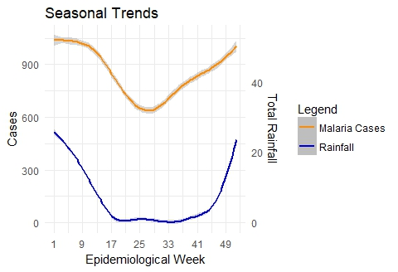
Mozambique experiences yearly average rainfall of 769mm with most of their rain coming between November and March⁸. Mid-year monthly rain totals fall as Mozambique enters its dry season. Since malaria is intrinsically linked with rainfall, cases of malaria rise and fall as the seasons change (Figure 1).
Health officials wish to combat this seasonal rise in malaria by implementing two main interventions. ITNs and IRS are both deployed in the country throughout the year. The rate at which they are used is decided at the district level, making Mozambique heterogeneous for intervention treatments. This heterogeneity makes it difficult to detect transmission reduction because of interventions at the national level, but does permit study at the district level to observe how malaria cases in each district change as the seasons progress and as interventions are applied. For the purposes of this analysis, indoor residual spray is assumed to be entirely completed in a district in the week it is first applied, though for logistic reasons it may take several weeks to fully cover a district.

Data
Seven years of weather data for all districts in Mozambique have been compiled in a database where individual days are summarized to be represented by Epidemiological week. This data includes rain totals, temperature, and other climate features. Reported cases from Mozambique’s main health ministry are used and incidence is reported at the district level by week. This incidence data is compromised solely of children since they are more likely to come into clinic for treatment than adults. As such, we get a better sense of transmission rates when looking at cases per 1000 children rather than per 1000 in total population. In addition, intervention data informing week and district in which either ITNs were distributed or indoor residual spray was applied is used to understand the relationship between interventions and malaria transmission rates.

Figure 1: Seasonal Trends in Rainfall (blue) and reported malaria cases in children (orange).

Results

Intervention Predictions
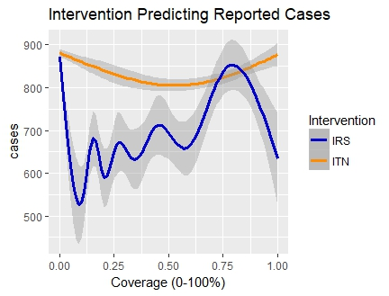
Insecticide treatment mosquito nets were believed to decay in effectiveness by .04% per week after the initial week of introduction. Intervention data was dispersed forward through time after the week it was introduced until another round of mosquito nets were provided or until its efficacy was believed to be zero. The protection rate for the nets varied from 0 to 1 and was used to predict malaria cases. It was hypothesized that with in the weeks where the mosquito nets’ protection was at its greatest, there would be fewer children arriving in the clinic with malaria. A few conflicts with the data prevent its predictive power from being stronger. First, it may be that health officials dispense mosquito nets at the peak of outbreaks, or more often in the wet season when malaria rates are high. Since the incubation period prior to the presentation of symptoms can span from 2 to 8 weeks, the first few weeks where mosquito nets are most effective may still have high malaria rates due to this lag in symptom development. Second, it is believed that mosquitos can develop some resistance to the insecticide used. If the nets have been implemented repeatedly in a region, mosquitos may be less sensitive to this intervention and malaria rates may not decline in the manner expected. Additionally, while malaria nets work remarkably well in controlled clinical settings, the proper usage of such in practice at least slightly diminished. While it was stated previously that it is uncommon for nets to be used for blatantly ‘off label’ reasons, carelessness in maintaining the nets securely around beds, keeping them closed prior to retiring to bed, and moving in and out of the nets for household activities all can contribute to the nets not fully protecting an individual from mosquito bites. It is for these reasons and likely many more that application of insecticide treated mosquito nets does not predict a decline in malaria rates at a statistically significant level.
Indoor residual spray is believed to have an efficacy decay of 1% per week following application. In this analysis, we assumed that indoor residual spray was applied to an entire district in one week and had a 100% protection rate at that time. Unfortunately, application of the spray takes time and resources that force its dispersion through a district to take months to complete. As a result, it is unsurprising that indoor residual spray did not predict changes in reported malaria cases at a statistically significant level. Figure 2 shows that indoor residual spray had an even more erratic prediction line than that for insecticide treated mosquito nets.
While these interventions did not prove to be significant in reducing malaria cases, a mountain of epidemiological data does suggest that they both can mitigate malaria transmission in regions like Mozambique, where we have made progress in decreasing the incidence of malaria each year.

Figure 2: Intervention Coverage rates spanning 0% to 100% predicting reported malaria cases.

Rainfall Lag Predictions
Rainfall is crucial in the life cycle of the malaria protozoan. This is largely due to their need for mosquito hosts, whose young are hatched and grow in stagnant waters. Because of this, incidence of malaria often rises in the weeks following rainfall. What remains to be proven is how far back epidemiologists should look when predicting where malaria rates may surge after it rains. Previous research has suggested that malaria rates rise sometime between 2 and 8 weeks following heavy rains___. Using this information, cases of malaria reported each week in the districts of Mozambique were paired with total rainfalls from 2, 4, and 8 weeks prior. Quasi-Poisson models were then fit to the data to ascertain which of these variables might provide the best inference about malaria cases that may occur following rainfall. All three rain lag variables predicted malaria cases at a statistically significant level. A test of correlation between rain lag variables was performed to confirm that their relationships were not so tightly linked to contribute identical or highly similar
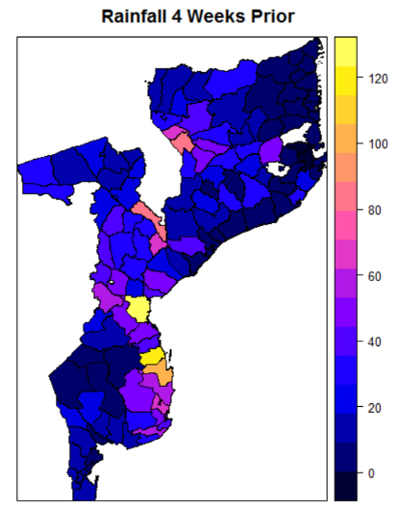
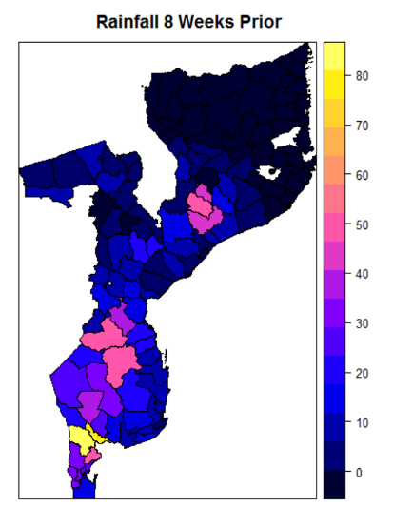
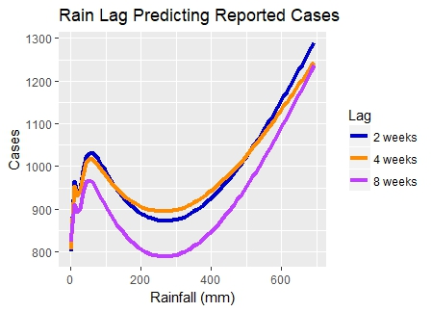
Figure 3 (above): Lag of 2, 4, and 8 weeks of rainfall predicting number of reported cases of malaria. 2 and 4-week lags predict nearly identically.
Figure 4 (right): Quadrant maps- Upper left map depicts incidence of malaria in week 2 of 2016. Upper right is rainfall 2 weeks prior. Lower left is rainfall 4 weeks prior. Lower right is rainfall 8 weeks prior.

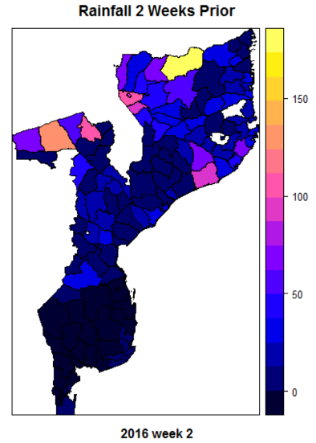
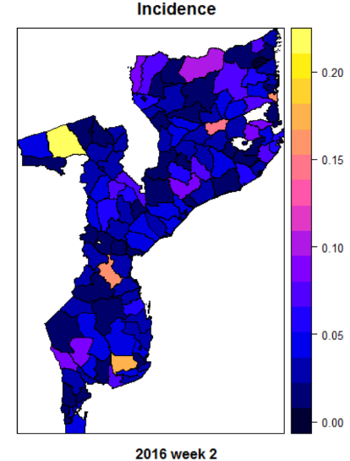
information to the model. No two-variable pair between the three lag variables was statistically significant so all were left in the final model. Additionally, we ascertained the mutual information provided by each variable pair and determined that knowledge of one variable did not reduce the relevant predictive power provided by the other.
As is shown in Figure 3, all three lag variables predicted cases of malaria in nearly identical ways. This is useful information because it allows public health officials to anticipate a wide window of malaria cases following rainfall. If officials anticipated a time frame of only 2 weeks leading to a surge in cases, they may understock health clinics or misappropriate funding/resources in areas that will ultimately see a rise in cases for two months following rainfall. Figure 4 serves as an example for the variability in regional reported cases due to

rainfall. Shown in the upper left-hand map is the incidence of malaria by district in Mozambique in the second week of 2016. This week comes at the peak of Mozambique’s wet season and as such, malaria rates are elevated from those expected mid-year. In the upper righthand map, rainfall from 2 weeks prior is shown. Below these are rainfalls from 4 weeks prior (left) and 8 weeks prior (right). This figure reflects that in some areas, it seems heavy rainfall 2 weeks prior to the reported week predict a rise in cases, but it can also be seen that rainfall 4 and 8 weeks prior, but no rainfall 2 weeks prior, still can indicate a rise in malaria cases.

Temperature Modeling
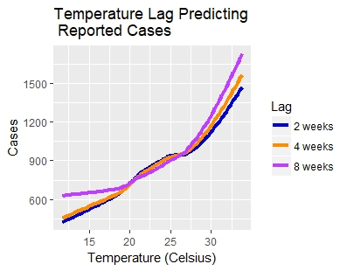
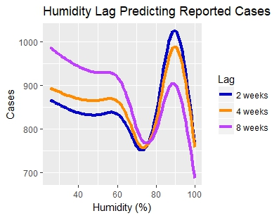
While rainfall is a necessary factor in the life cycle of malaria, temperatures also play an important role. The lowest temperature in a given day needs to be warm enough to not kill mosquitos or the malaria they house. It is because of this that malaria is not as endemic in colder parts of the world. Since we know that temperature is an important aspect of malaria’s life cycle, modeling it here can shed light on how temperature trends can predict a rise in incidence of malaria. Like rainfall, lag variables for temperature were made for 2, 4, and 8 weeks prior to a child’s arrival at the clinic. Unlike rainfall, temperature appears to predict reported cases in a highly linear fashion. Figure ___ shows that as temperatures rise, reported cases rise as well. This is true for all three lag variables. A test of correlation between the lag variables indicated that moderate correlation between the variables. Partial F tests of reduced models each missing one temperature lag variable were compared to a model containing all 3 lag periods. All tests exhibited significance and thus all 3 temperature lag variables contribute moderately unique information to a model estimating number of reported cases.

Humidity Modeling
Dry heat is no good for the malaria protozoan. It must also be humid. This is partially why rainfall can predict a rise in cases. To assess how changes in humidity affect reported cases, humidity lag variables were created like those for rain and temperature. Humidity appears to be complexly related to malaria incidence. Unlike temperature, it does not predict cases in a linear fashion, and behaves more like rainfall. It is logical that rainfall and humidity predict in similar ways since they are intrinsically linked. Figure___ shows how 2, 4, and 8-week humidity lags predict malaria cases. While humidity does predict malaria at a statistically significant level, it alone does not consistently predict cases well and should be incorporated into a model containing other weather variables.

Discussion and Conclusions
It remains to be proven that interventions can have a detectable impact on malaria cases when applied. Perhaps greater significance would have been seen her if a finer grain of precision were used in estimating protection rates in a district over time. However, this lack of statistical significance should not suggest that such interventions are ineffective.

In fact, Figure 2 shows that with increasing net coverage, malaria cases are not predicted to rise or fall. The pattern demonstrated in the plot, may be suggestive of seasonal malaria increases at the top end of coverage. It makes sense for health officials to send nets to areas where malaria rates are high. In the first couple weeks of net deployment, malaria case will still be high even if the nets are working. It also makes sense that malaria rates rise as coverage falls to 0. This parabolic shape of insecticide treated mosquito net application is logical, though not statistically significant.
Their worth has been proven from previous study and eliminating the usage of such would likely result in higher transmission rates. It is believed that large health campaigns pushed throughout Africa in the last decade has been the driving force behind declining malaria rates throughout the continent.
For the purposes of incidence prediction, total rainfall seen in a week will predict the number of reported malaria cases for 2-8 weeks into the future. Public health officials and epidemiologists can use this information to properly allocate resources to clinics and perhaps better place interventions like insecticide treated mosquito nets and indoor residual sprays.
It appears that all are important when considering where cases of malaria may surge in the future.

- Fact sheet about Malaria. (n.d.). Retrieved November 24, 2017, from http://www.who.int/mediacentre/factsheets/fs094/en
- Ryan, C. (2011). School of GeoSciences. Retrieved November 24, 2017, from https://www.geos.ed.ac.uk/homes/cryan/moz_met.html
- Oaks, S. C. (1991). Malaria: obstacles and opportunities. Retrieved November 24, 2017.
- Country Profiles: Mozambique. (2016). Retrieved November 24, 2017, from http://www.who.int/malaria/publications/country-profiles/profile_moz_en.pdf
- Lim, S. S., Fullman, N., Stokes, A., Ravishankar, N., Masiye, F., Murray, C. J., & Gakidou, E. (2011). Net benefits: A multicountry analysis of observational data examining associations between insecticide-treated mosquito nets and health outcomes. PLoS Medicine, 8(9).
- Eisele, T. P., Thwing, J., & Keating, J. (2011). Claims about the misuse of insecticide-treated mosquito nets: Are these evidence-based? PLoS Medicine, 8(4), 2. https://doi.org/10.1371/journal.pmed.1001019
- Rainfall/Precipitation in Maputo, Mozambique. (n.d.). Retrieved November 29, 2017, from http://www/maputo.climatemps.com/precipitation.php

